REPORT ON REGELTECHNIEK WPO SESSION
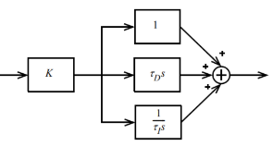
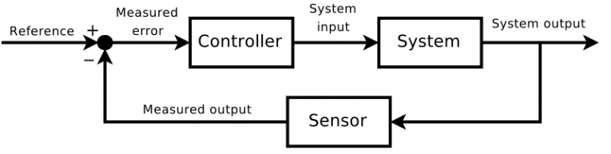
  - Date
Name 1, email1
Name 2, email2

Third session - Exercises

Consider the following control setup using control system toolbox
- Realize the systems: $G_{controller}\left(s\right)=1, G_{system}\left(s\right)=\frac{10}{1+5s}e^{-8s}, G_{sensor}\left(s\right)=\frac{0.5}{1+s}$.
- Apply constant 20 (Celsius) as reference signal. Simulation parameters: $fs=100Hz,t_{max}=100sec$. Calculate the system, measured outputs and the measured error, show them on the same figure.
- Display the Bode plot of the underlying system using Bode command. Estimate the gain margin, phase margin, crossover frequency using the Bode plot figure, compare your results with margin command.
- Design a P controller that has 60 degrees of phase margin
- What gain is needed? Define the controller accordingly. Check the new phase margin.
- Calculate the system, measured outputs and the measured error, show them on the same figure.
- What is the analytical steady-state error level (see the formula presentation file) and what is the measured one?
- Consider exercise b) but with a PI controller
- Use the gain obtained in b). Choose the dominant time constant for the integration time. Show the measured output, and what is the phase margin?
- Adjust the controller to have 60 degrees of phase margin again. Calculate the system, measured outputs and the measured error, show them on the same figure. What is the analytical steady-state error level and what is the measured one?
- Compare the reference signal with the measured outputs of P and PI controlled systems, show the error signals as well. Compare the settling times, rise times, overshoots, static gains, steady state errors. What conclusions do you draw?

Consider the following control setup using Simulink
- Realize the systems with the following parameters $G_{controller}\left(s\right)=1, G_{system}\left(s\right)=\frac{0.5}{s^{2}+0.11s+0.001}e^{-5s}, G_{sensor}\left(s\right)=1$
- Is the open-loop system stable? Show the unit step response.
- Is the closed-loop system stable? Show the unit step response.
- Display the Bode plot of the underlying system.
- Estimate the gain margin, phase margin, crossover frequency using the Bode plot figure.
- Design a P controller that have 45 degrees of phase margin. Apply 20 (Celsius) as step reference signal
- What gain is needed? Why? Define the controller accordingly
- Check the step response. Mark the settling time, compare the true set point (reference) signal with the actual measured value and show the error signal.
- What is the analytical steady-state error level and what is the measured one?
- Consider exercise b) but with a PI controller
- Use the gain obtained in c). Choose the dominant time constant for the integration time.
- Check the step response. Mark the settling time, compare the true set point (reference) signal with the actual measured value and show the error signal.
- What is the analytical steady-state error level and what is the measured one?
- Consider exercise c) but with a PID controller
- Use the gain obtained in b) and integration time obtained in c).
- Choose the second dominant time constant for the differentiation time.
- Check the step response. Mark the settling time, compare the true set point (reference) signal with the actual measured value and show the error signal.
- What is the analytical steady-state error level and what is the measured one?
- Compare the step responses from b)-d) with the reference signal and analyze the results. What conclusions can you draw?

