REPORT ON REGELTECHNIEK WPO SESSION
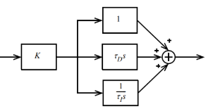
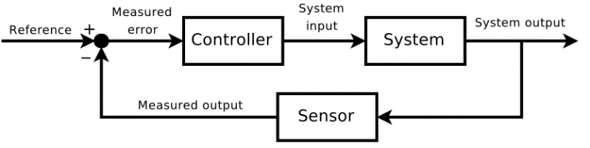
  - Date
Name 1, email1
Name 2, email2

FOURTH session - Exercises

Consider the following control setup using Simulink or Control toolbox
- Realize the systems with the following parameters $G_{controller}\left(s\right)=1, G_{system}\left(s\right)=\frac{5}{10s+1}e^{-5s}, G_{sensor}\left(s\right)=1$.
- Design a PID controller according to the open loop Ziegler-Nichols method.
- What is the delay and the time constant?
- What are the PID parameters?
- Analyze the output (rise time, settling time, error, overshoot) and the bode Characteristic (phase margin, gain margin).

Consider the following control setup using Simulink or Control toolbox
- Realize the systems with the following parameters $G_{controller}\left(s\right)=1, G_{system}\left(s\right)=\frac{1}{s(s+1)(s+2)}, G_{sensor}\left(s\right)=1$.
- Design a PID controller according to the closed loop Ziegler-Nichols method.
- Use a gadget to tune the gain of the controller.
- What is Kcrit and Pcrit?
- What are the PID parameters?
- Analyze the output (rise time, settling time, error, overshoot) and the bode Characteristic (phase margin, gain margin).

Consider the following control setup using Simulink or Control toolbox
- Realize the systems with the following parameters $G_{controller}\left(s\right)=1, G_{system}\left(s\right)=\frac{1}{s-2}, G_{sensor}\left(s\right)=1$
- Is the open-loop system stable? Show the unit step response.
- Is the closed-loop system stable? Show the unit step response.
- Display the Bode plot of the underlying system.
- Estimate the gain margin, phase margin, crossover frequency using the Bode plot figure.
- Design a P controller. At what minimum gain value is the system already stable?
- What gain is needed? Why? Define the controller accordingly
- Design a PI controller with a phase margin of 60 degrees.
- What in the integration time and the gain?
- Analyze the output (rise time, settling time, error, overshoot) and the bode Characteristic (phase margin, gain margin).

